**Exercises in JavaScript**

**Date:04.02.2023**

**Bult-in JavaScript Methods**

1. **Encode and Decode URL in JavaScript**

JavaScript provides two standard built-in methods to encode full URL and single URL parameter:

1. **encodeURL()**- The encodeURI() function is used to encode a full URI.
2. **encodeURIComponent()** - The encodeURIComponent() function encodes a URI component.

These 2 methods differ in which characters they do encode.

* **encodeURL()** function encodes special characters, except: , / ? : @ & = + $ #
* **encodeURIComponent()** function encodes special characters. In addition, it encodes the following characters: , / ? : @ & = + $ #

Why do they differ? Because they are meant for different uses:

* **encodeURI()** is meant to encode a full URL
* 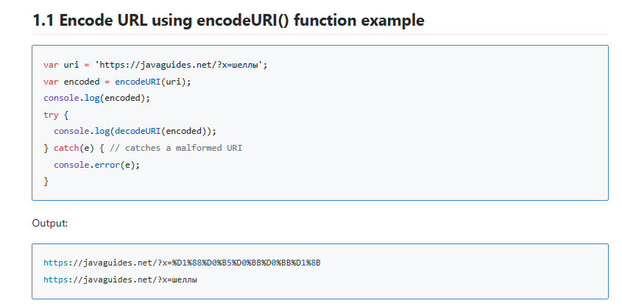**encodeURIComponent()** is meant to encode a single URL parameter value

**\* "malformed URI sequence" occurs when URI encoding or decoding wasn't successful.**

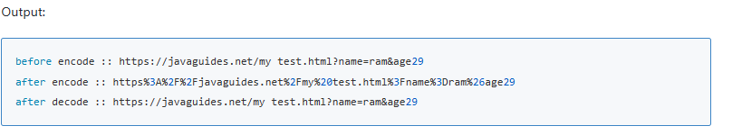

* 1. **Encode URL Component using encodeURIComponent() function**

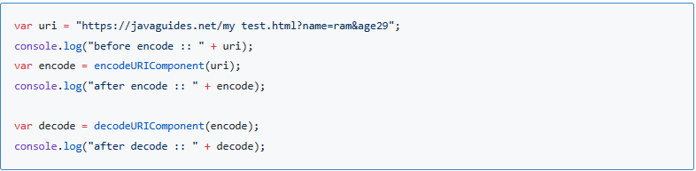

1. **Parsing numbers**

**2.1 ParseInt**

**The given string “100” parse in number an integer**

* 1. **ParseFloat**

**The given string “82.5” parse in float and in console log print the type**

1. **Array Methods**

**3.1** **JavaScript Array fill()**

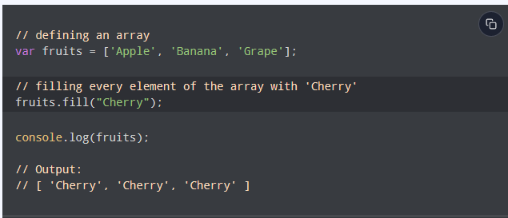

* 1. **Javascript Array join()**

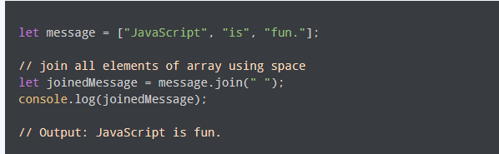

**3.3** **JavaScript Array concat()**

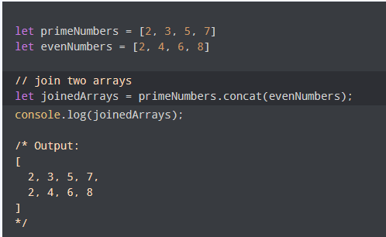

* 1. **JavaScript Array find()**

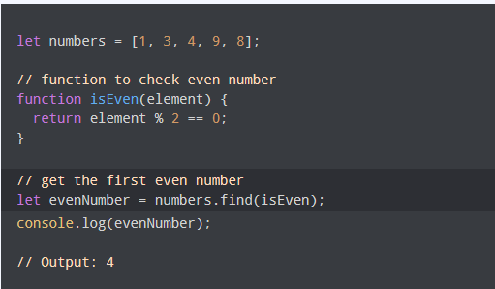

**3.5 JavaScript Array map()**

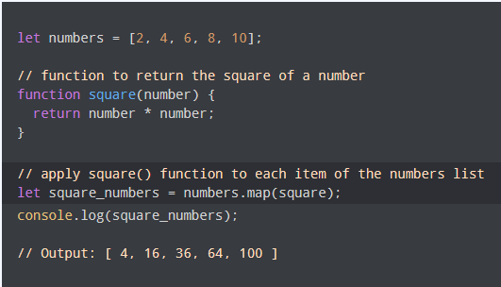

* 1. **Javascript Array forEach()**

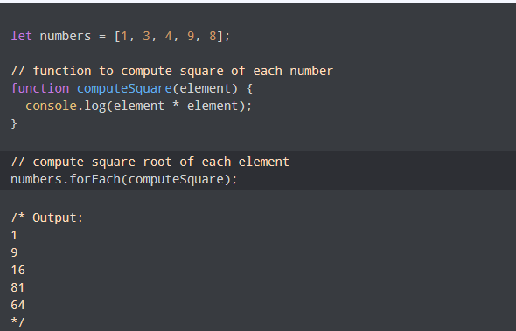

**4.Maths Methods**

**4.1 JavaScript Math.min()**

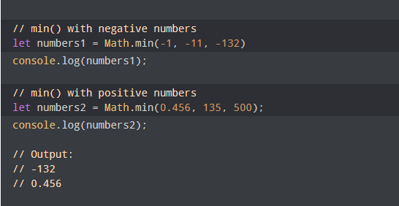

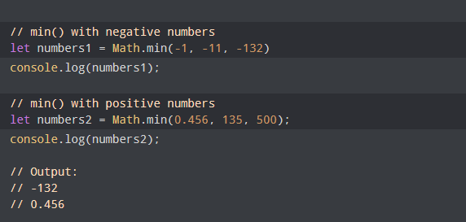

**4.2 Math.min() with Arrays**

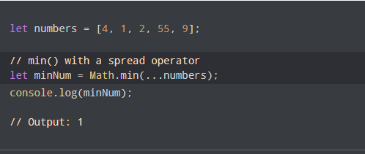

**4.3 Math max()**

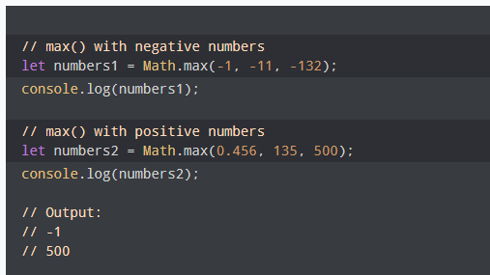

**4.4 Math.max() with Arrays**

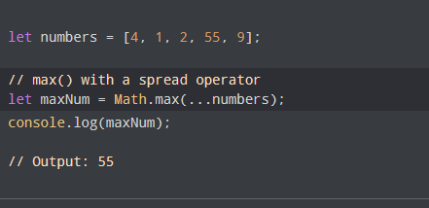

1. **Format The Date**

// program to format the date

// get current date

let currentDate = new Date();

// get the day from the date

let day = currentDate.getDate();

// get the month from the date

// + 1 because month starts from 0

let month = currentDate.getMonth() + 1;

// get the year from the date

let year = currentDate.getFullYear();

// if day is less than 10, add 0 to make consistent format

if (day < 10) {

day = '0' + day;

}

// if month is less than 10, add 0

if (month < 10) {

month = '0' + month;

}

// display in various formats

const formattedDate1 = month + '/' + day + '/' + year;

console.log(formattedDate1);

const formattedDate2 = month + '-' + day + '-' + year;

console.log(formattedDate2);

const formattedDate3 = day + '-' + month + '-' + year;

console.log(formattedDate3);

const formattedDate4 = day + '/' + month + '/' + year;

console.log(formattedDate4);